**Prepare Data**

Run SQL Server Scripts to create Views

Create Excel files with matching column name and data type as Views

Use SQL Server Import and Export Data app to export data to Excel files

Choose Data Source: SQL Server Native Client 11.0

Server name

Database

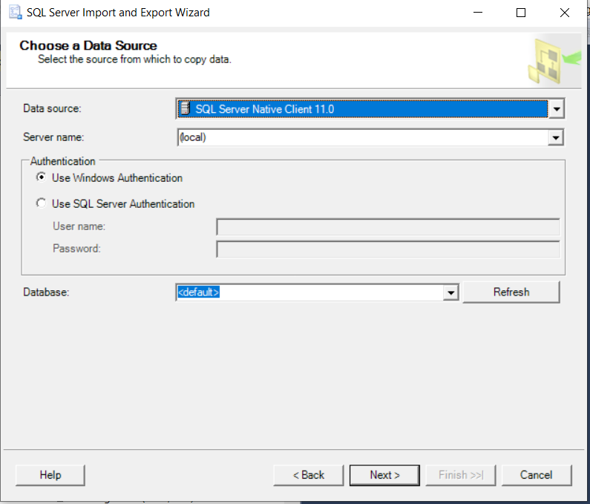

Choose Microsoft Excel for Destination

Browse Excel file created in your computer

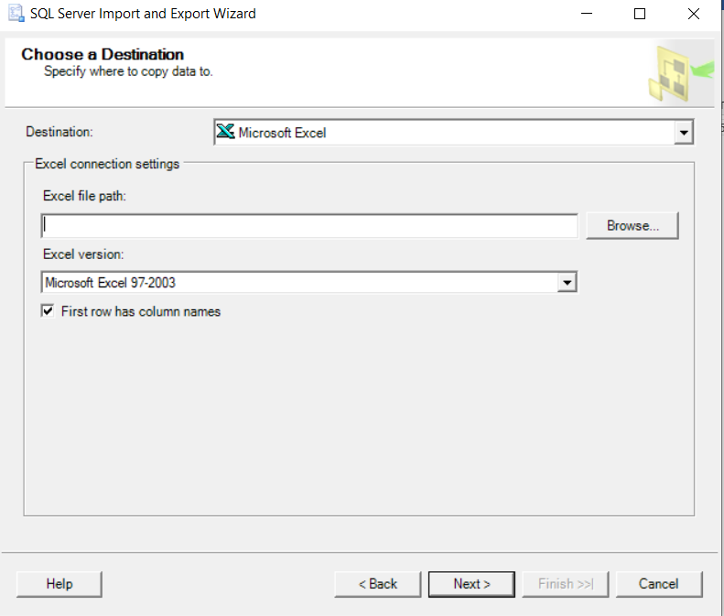

Chose Source (view), it will display Destination

Chick Edit Mapping

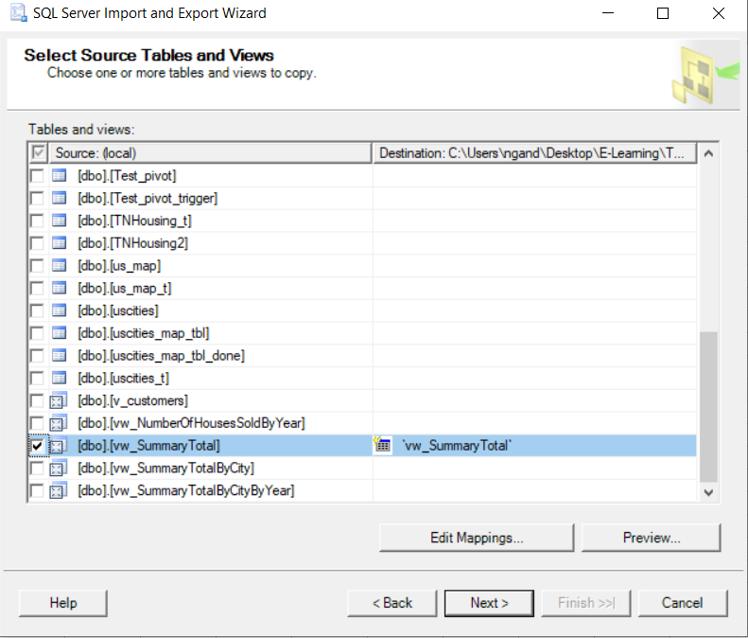

Copy data

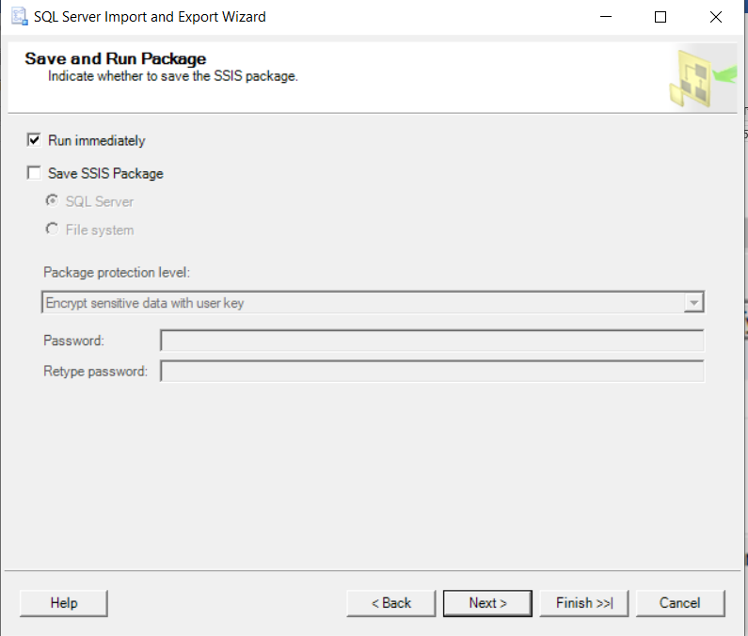

Finish and successfully copy data

